Worn teeth
Teeth can wear prematurely for a number of reasons including attrition, erosion, abrasion and abfraction. Wear patterns can help determine the cause of the wear. If possible, it is important to determine the etiology of the wear, as it influences treatment choices and prognosis. Before deciding upon a course of treatment, a number of questions must be answered. They are the following:
- Are all teeth wearing or are only certain teeth wearing?

Full arch wear
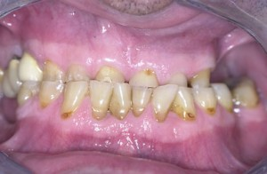
If all teeth show signs of wear then the patient most likely has lost vertical dimension which is the distance between a person’s nose and their chin when their teeth are together as depicted as the distance “A” in the following diagram.
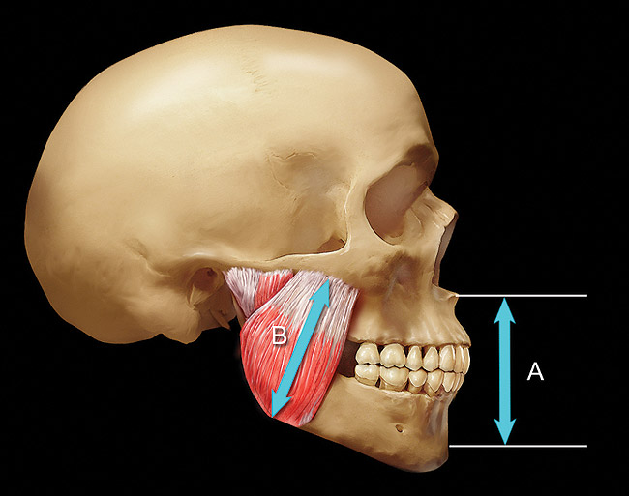

A pleasing facial proportion is when the distance from the hair-line to eyebrow, the distance from eyebrow to tip of nose and the distance from the tip of nose to chin are the same.

The loss of vertical dimension often results in a less youthful appearance.

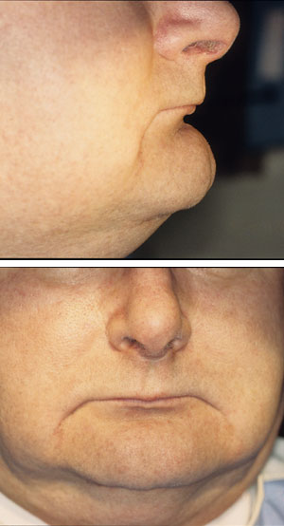

Restoring vertical dimension returns a more youthful appearance.

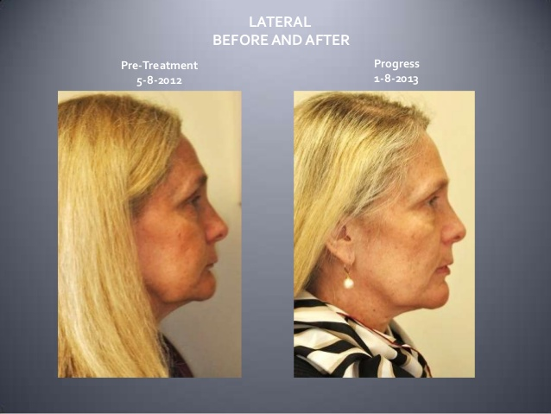
When restoring vertical dimension in a patient who has full arch wear, the amount of remaining tooth structure must be evaluated. In order to support a crown, there needs to be at least 3-4mm of tooth structure remaining in 360 degrees around the circumference of the tooth. If that minimum amount of tooth structure does not exist as is often seen with severe bruxism, the patient’s bite must be “opened” by increasing the vertical dimension. This requires placing a crown or biting surface restoration on every tooth in the upper or lower arch. If insufficient tooth structure remains on the teeth in both arches, a crown or restoration may be required on every tooth in both arches.
- Are only select teeth are wearing?
Front tooth wear only
Usually when tooth structure is lost (resulting in a shorter tooth) the gum tissue and bone move with the teeth more into the mouth until an excessive amount of gum tissue shows above the teeth. This presentation of excessive gingival display has been described by Spear as dento-alveolar extrusion and is shown in the following two images. They both images show patients with a normal bite and minimal wear on their back teeth.

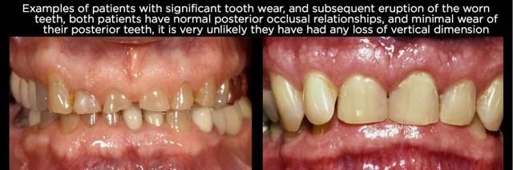
Since only their front teeth have worn most likely their vertical dimension has not been lost and the restorative process can be less involved. One key in making this diagnosis is to note that the gingival height of the cuspids are higher than the gingival height of the central and lateral teeth yet the incisal edge positions of their front teeth have not changed appreciably.
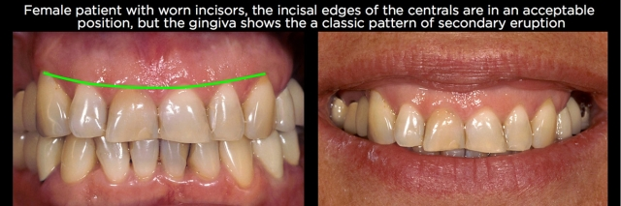
In such cases the treatment options may include orthodontics (with or without surgery) to intrude the erupted teeth back to their original position, crown lengthening to reduce the gingival display by exposing more of the root or rarely extraction of the erupted teeth and replacement with crowns or implants. If the teeth have minimal pre-existing dental restorations, orthodontic intrusion followed by minimal restorative treatment is preferred as doing so will be the least invasive and most economical approach.
Orthodontic treatment is often useful to increase overjet if the cause of the wear is a result of a restricted chewing pattern as described by Kois. However, if the patient declines orthodontic treatment and the involved teeth need restorations then crown lengthening is often the best choice. Rarely, the teeth are extracted or the patient requires surgical orthodontic treatment.
- Are the front teeth in an acceptable position?

Central Incisor position
“Begin with the end in mind” was a concept popularized by the late Stephen Covey. In regards to dental reconstruction, it is important to determine the desired final tooth position and gingival levels before beginning treatment. This assessment can only be made by evaluating tooth position in relation to the soft tissues of the face. In most cases, when the mouth is slightly open, showing 2mm of the biting edge of front teeth beneath the upper lip on younger patients or at least the very edge of front teeth on mature patients looks best. Without any teeth showing at rest, the patient looks edentulous (toothless) until mouth movement proves otherwise.

Once the position of the incisal edge of the front teeth is settled upon, the position of the remaining teeth can be planned. This concept of Facial Generating Treatment Planning was introduced by Spear.
- Is the size of the front teeth acceptable?
Natural teeth are about 20% longer than they are wide. Worn teeth often become square as the biting edges wear away.
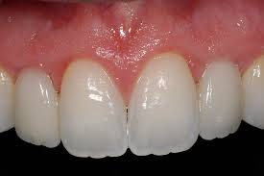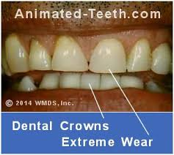

Restoring the length of upper front teeth in a selective wear case can require orthodontics to intrude the worn teeth or crown lengthening to expose more tooth structure. Surgical Crown Lengthening (SCL) is an option for patients who are unwilling to undergo orthodontic treatment. To be a candidate for SCL, a tooth must have 8-9mm of root remaining in bone following surgery. If a patient would have less than 8mm after SCL, orthodontic intrusion is the preferred choice.
- Are the extruded teeth tipped severely outward or inward?
The greater the front teeth are tipped, the more difficult it will be to restore the teeth. In such cases, orthodontics is the better choice. Also, if the teeth do not fit together properly as occurs when teeth hit end on end or significantly overlap each other, orthodontics is preferred.
- Are the teeth restorable?
If not, then their removal and replacement may be the best treatment option.
Sample cases:
Restricted chewing pattern
- Full arch wear with loss of vertical dimension
- Central incisor position acceptable
- Upper and lower central incisors “square” from pathway wear
- Front tooth incisal edge positon acceptable
- Treatment plan involves orthodontics and restorative
Joe T

Dento-alveolar extrusion
- Severe front teeth wear with minimal back teeth wear and likely no loss of vertical dimension
- Upper front teeth, gum and bone moved more into her mouth as teeth wore resulting in excessive gingival display “gummy smile”
- Extruded teeth worn “square”
- Front teeth position acceptable
- The treatment plan could be to reposition (intrude) patient’s front teeth through orthodontics or increase their length through SCL. In this case, patient chose SCL followed by restoration of front teeth.

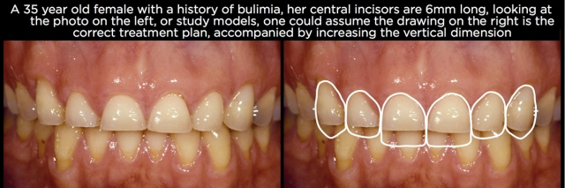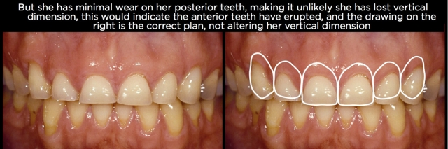
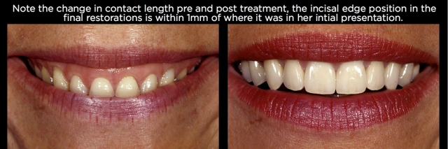
Restricted chewing pattern with unstable Temporomandibular Joint (TMJ) position
- Back teeth as well as front teeth require restoration
- Front teeth splaying (spaces opening between teeth) from insufficient overjet
- Patient has history of clicking and popping resulting from unstable TMJ
- Central incisor position and size acceptable
- Patient unwilling to undergo orthodontic treatment
- Treatment plan included opening vertical allowing for a stable joint position followed by restoration of all teeth at a bite that maintains a healthy joint position.
?

